Assignment 6
Name:-Yadnesh Patil
PRN:-123B1D034
Assignment 6 :
mysql> CREATE DATABASE ASSIGNMENT_6_E_commerce_system;
mysql> USE ASSIGNMENT_6_E_commerce_system;
mysql> SHOW DATABASES;
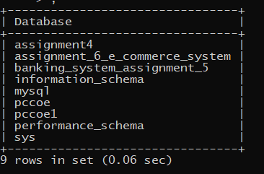
CREATE TABLES:
- Customers (customer_id, name, email, city)
mysql> CREATE TABLE Customers(customer_id INT PRIMARY KEY,name VARCHAR(100),email VARCHAR(100),city VARCHAR(50));
- Orders (order_id, customer_id, order_date, total_amount)
mysql> CREATE TABLE Orders (order_id INT PRIMARY KEY,customer_id INT,order_date DATE,total_amount INT, FOREIGN KEY (customer_id) REFERENCES Customers(customer_id));
- Products (product_id, product_name, category, price)
mysql> CREATE TABLE Products (product_id INT PRIMARY KEY,product_name VARCHAR(100),category VARCHAR(100),price INT);
- Order_Items (order_item_id, order_id, product_id, quantity, subtotal)
mysql> CREATE TABLE Order_Items (order_item_id INT PRIMARY KEY,order_id INT,product_id INT,quantity INT,subtotal INT,FOREIGN KEY (order_id) REFERENCES Orders(order_id),FOREIGN KEY (product_id) REFERENCES Products(product_id));
- Sellers (seller_id, seller_name, city)
mysql> CREATE TABLE Sellers (seller_id INT PRIMARY KEY,seller_name VARCHAR(100),city VARCHAR(100));
- Product_Sellers (seller_id, product_id, stock)
mysql> CREATE TABLE Product_Sellers (seller_id INT,product_id INT,stock INT,PRIMARY KEY (seller_id, product_id),FOREIGN KEY (seller_id) REFERENCES Sellers(seller_id),FOREIGN KEY (product_id) REFERENCES Products(product_id));
INSERTING VALUES INTO TABLES
- Customers
mysql> INSERT INTO Customers (customer_id, name, email, city) VALUES -> (1, 'Atharva Zope', '10datharvazope@gmail.com', 'Pune'), -> (2, 'Adwait Kamble', 'adwait.kamble@email.com', 'Mumbai'), -> (3, 'Advait Nathe', 'advait.nathe@email.com', 'Nashik'), -> (4, 'Devraj Bafna', 'devraj.bafna@email.com', 'Pune'), -> (5, 'Pratiksha Hazare', 'pratiksha.hazare@email.com', 'Mumbai'), -> (6, 'Vishwajeet Bhamre', 'vishwajeet.bhamre@email.com', 'Nagpur'), -> (7, 'Rohit Sharma', 'rohit.sharma@email.com', 'Delhi'), -> (8, 'Anjali Singh', 'anjali.singh@email.com', 'Bangalore'), -> (9, 'Karan Mehta', 'karan.mehta@email.com', 'Hyderabad'), -> (10, 'Neha Patil', 'neha.patil@email.com', 'Pune');

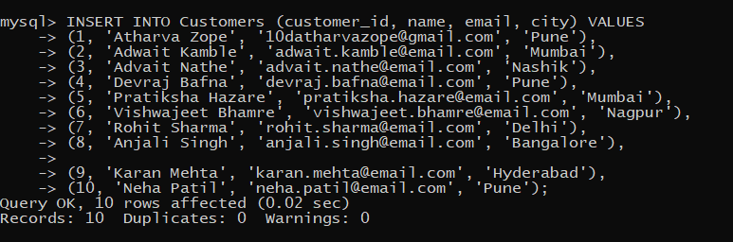

- Products
mysql> INSERT INTO Products (product_id, product_name, category, price) VALUES
-> (201, 'Laptop', 'Electronics', 50000),
-> (202, 'Book', 'Education', 500),
-> (203, 'Headphones', 'Electronics', 1500),
-> (204, 'Mobile Phone', 'Electronics', 25000),
-> (205, 'Table', 'Furniture', 3000),
-> (206, 'Chair', 'Furniture', 1500),
-> (207, 'Monitor', 'Electronics', 10000),
-> (208, 'Keyboard', 'Electronics', 500),
-> (209, 'Pen', 'Stationery', 10),
-> (210, 'Notebook', 'Stationery', 50); 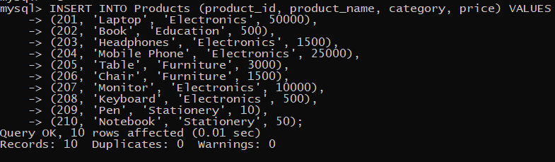

- Sellers
mysql> INSERT INTO Sellers (seller_id, seller_name, city) VALUES
-> (401, 'TechMart', 'Pune'),
-> (402, 'BookHub', 'Mumbai'),
-> (403, 'SoundWave', 'Nashik'),
-> (404, 'FurniStore', 'Delhi'),
-> (405, 'GadgetWorld', 'Bangalore'),
-> (406, 'StationeryHouse', 'Hyderabad'),
-> (407, 'ElectroMart', 'Nagpur'),
-> (408, 'HomeStyle', 'Chennai'),
-> (409, 'OfficeSupplies', 'Pune'),
-> (410, 'DigitalCorner', 'Kolkata'); 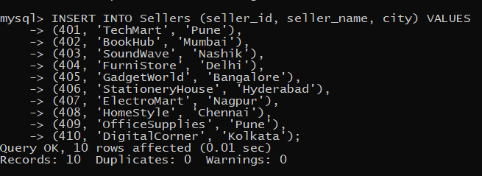
- Orders
mysql> INSERT INTO Orders (order_id, customer_id, order_date, total_amount) VALUES
-> (101, 1, '2024-09-25', 500),
-> (102, 2, '2024-09-26', 1000),
-> (103, 3, '2024-09-27', 1500),
-> (104, 4, '2024-09-28', 3000),
-> (105, 5, '2024-09-29', 50000),
-> (106, 6, '2024-09-30', 10000),
-> (107, 7, '2024-10-01', 25000),
-> (108, 8, '2024-10-02', 3000),
-> (109, 9, '2024-10-03', 50),
-> (110, 10, '2024-10-04', 10); 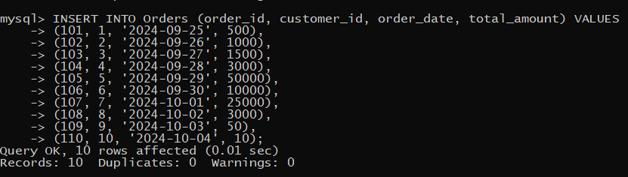
- Order_Items
mysql> INSERT INTO Order_Items (order_item_id, order_id, product_id, quantity, subtotal) VALUES
-> (301, 101, 202, 1, 500),
-> (302, 102, 203, 1, 1500),
-> (303, 103, 204, 1, 25000),
-> (304, 104, 205, 1, 3000),
-> (305, 105, 201, 1, 50000),
-> (306, 106, 207, 1, 10000),
-> (307, 107, 208, 1, 500),
-> (308, 108, 206, 2, 3000),
-> (309, 109, 209, 5, 50), 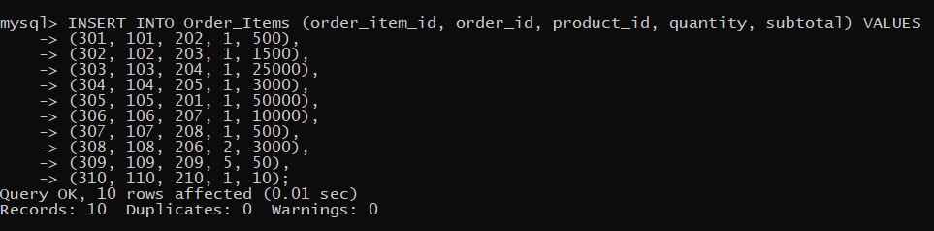
- Product_Sellers
mysql> INSERT INTO Product_Sellers (seller_id, product_id, stock) VALUES
-> (401, 201, 10),
-> (402, 202, 50),
-> (403, 203, 30),
-> (404, 204, 15),
-> (405, 205, 20),
-> (406, 206, 25),
-> (407, 207, 10),
-> (408, 208, 50),
-> (409, 209, 100),
-> (410, 210, 200);
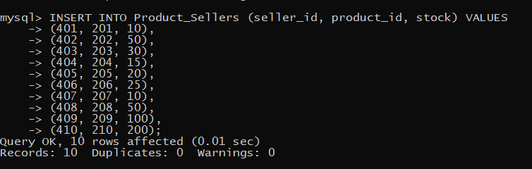

DISPLAYING TABLES
- Customers
mysql> SELECT * FROM Customers;
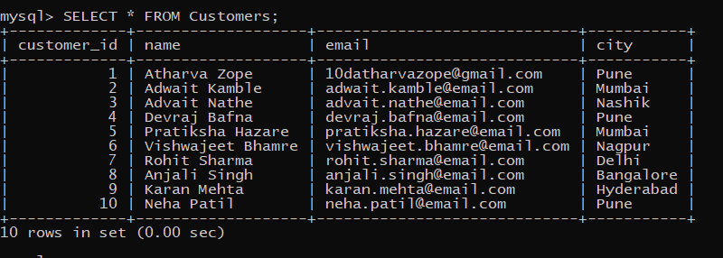
- Orders
SELECT * FROM Orders;
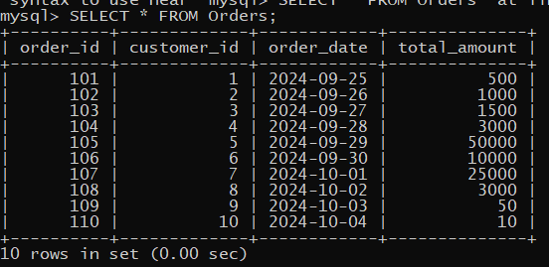

- Products
mysql> SELECT * FROM Products;
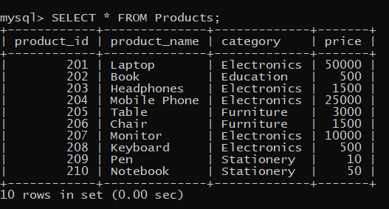
- Order_Items
mysql> SELECT * FROM Order_Items;
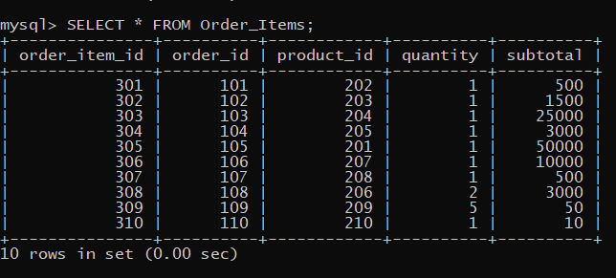

- Sellers
mysql> SELECT * FROM Sellers;
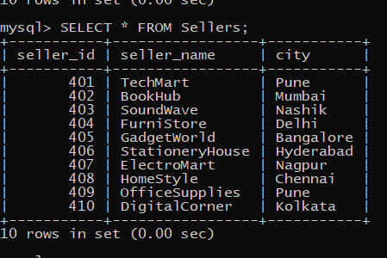

- Product_Sellers
mysql> SELECT * FROM Product_Sellers;
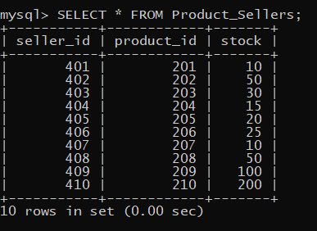
Solve following SQL Queries:

1. Retrieve all customers along with their corresponding orders (including customers who
haven't ordered)
SELECT c.customer_id, c.name, c.email, c.city, o.order_id, o.order_date, o.total_amount FROM Customers c LEFT JOIN Orders o ON c.customer_id = o.customer_id;
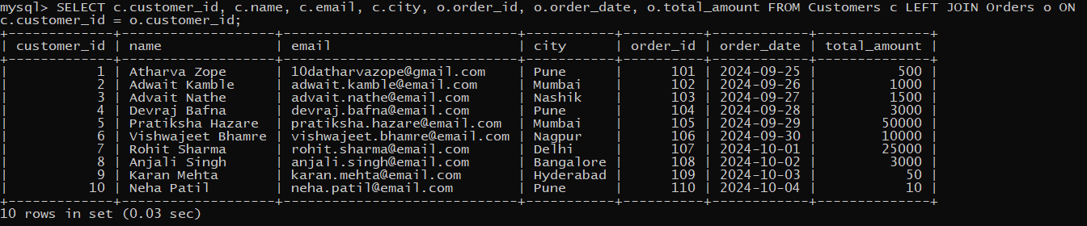

2. List all orders along with the product names and their quantities.
SELECT o.order_id, p.product_name, oi.quantity FROM Order_Items oi JOIN Products p ON oi.product_id=p.product_id JOIN Orders o ON oi.order_id=o.order_id;
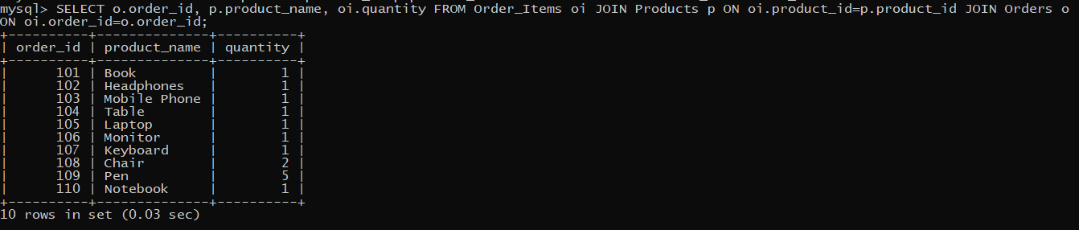

3. Find the total number of orders placed by each customer.
SELECT c.customer_id, c.name, COUNT(o.order_id) AS total_orders FROM Customers c LEFT JOIN Orders o ON c.customer_id = o.customer_id GROUP BY c.customer_id, c.name;
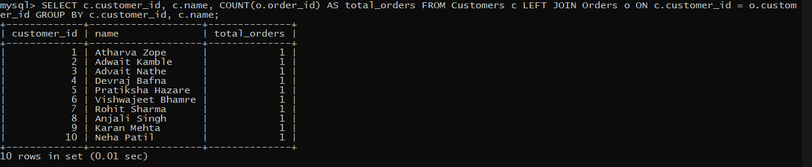
4. Find the total number of products available in each category.
SELECT category, COUNT(*) AS total_products FROM Products GROUP BY category;
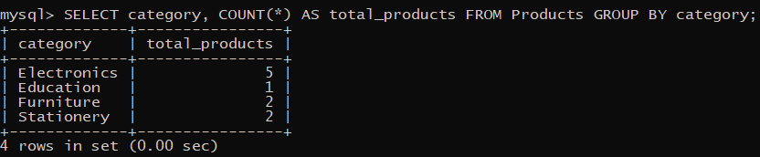
5. Retrieve the order details, including customer name and total amount, for all orders
placed in the last 30 days.
SELECT o.order_id, c.name, o.total_amount FROM Orders o JOIN Customers c ON o.customer_id = c.customer_id WHERE o.order_date >= CURDATE() - INTERVAL 30 DAY;
6. Retrieve the names of sellers who sell a specific product (e.g., "Laptop").
SELECT DISTINCT s.seller_name FROM Sellers s JOIN Products p ON s.seller_id = p.product_id WHERE p.product_name = 'Laptop';

7. Show all customers who have never placed an order.
SELECT * FROM Customers WHERE customer_id NOT IN (SELECT DISTINCT customer_id FROM Orders);
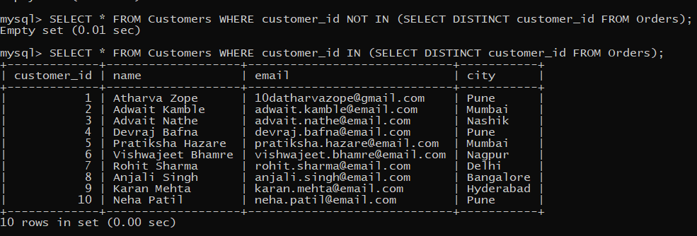

8. Retrieve details of orders where the total amount is greater than the average order total.(
solve suing subquery)
SELECT * FROM Orders WHERE total_amount > (SELECT AVG(total_amount) FROM Orders);
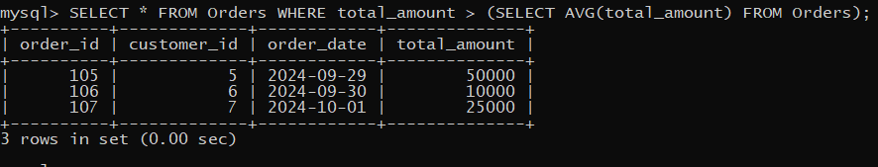

9. Find customers who have placed at least two orders.
SELECT customer_id FROM Orders GROUP BY customer_id HAVING COUNT(order_id) >= 2;

10. Find the top 3 most ordered products based on quantity sold.
SELECT p.product_name, SUM(oi.quantity) AS total_sold FROM Order_Items oi JOIN Products p ON oi.product_id = p.product_id GROUP BY oi.product_id ORDER BY total_sold DESC LIMIT 3;
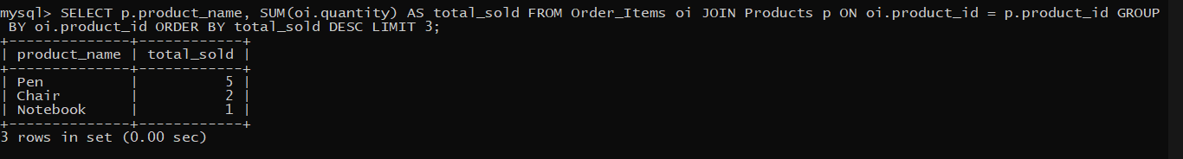

11. Display the product names that are sold by multiple sellers.
SELECT product_name FROM Products WHERE product_id IN (SELECT product_id FROM (SELECT product_id, COUNT(DISTINCT seller_id) AS seller_count FROM Sellers GROUP BY product_id HAVING seller_count > 1) AS multi_seller);
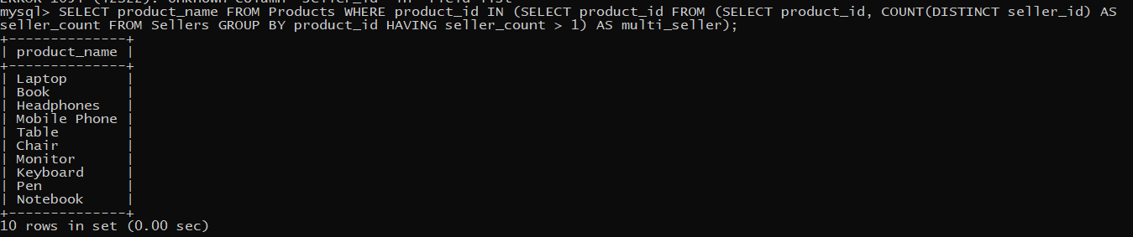

12. Retrieve sellers who have never sold any product.
SELECT * FROM Sellers WHERE seller_id NOT IN (SELECT DISTINCT seller_id FROM Products);

13. Find all products that have never been ordered.
SELECT * FROM Products WHERE product_id NOT IN (SELECT DISTINCT product_id FROM Order_Items);

14. Retrieve the names of customers who have placed the highest number of orders.
SELECT customer_id FROM Orders GROUP BY customer_id ORDER BY COUNT(order_id) DESC LIMIT 1;
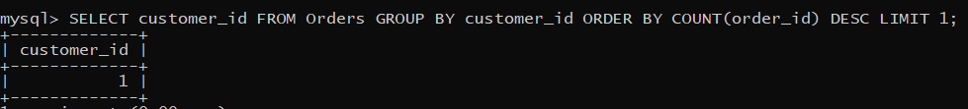

15. Find all customers who have ordered more than 5 different products.
(Hint: Use COUNT DISTINCT on product_id.)
SELECT o.customer_id FROM Orders o JOIN Order_Items oi ON o.order_id = oi.order_id GROUP BY o.customer_id HAVING COUNT(DISTINCT oi.product_id) > 5;

16. Find products that are sold by at least two different sellers but have never been ordered.
(Hint: Use HAVING COUNT(DISTINCT seller_id) > 1 and NOT EXISTS.)

SELECT ps.product_id FROM Product_Sellers ps GROUP BY ps.product_id HAVING COUNT(DISTINCT ps.seller_id) > 1 AND NOT EXISTS (SELECT 1 FROM Order_Items oi WHERE oi.product_id = ps.product_id);

17. Find the customer who has spent the most money overall.
(Hint: Use SUM and ORDER BY.)
SELECT customer_id, SUM(total_amount) AS total_spent FROM Orders GROUP BY customer_id ORDER BY total_spent DESC LIMIT 1;
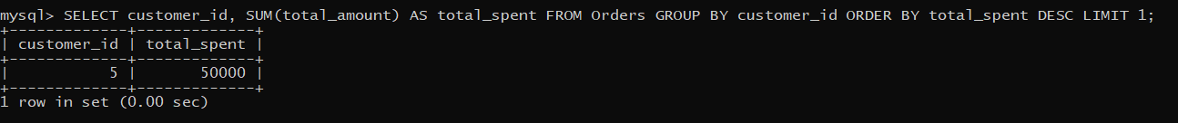

18. Find all customers who have either placed an order or live in the same city as a seller.
(Hint: Use UNION to combine customers who placed orders and those in seller cities.)
SELECT customer_id FROM Orders UNION SELECT customer_id FROM Customers WHERE city IN (SELECT DISTINCT city FROM Sellers);
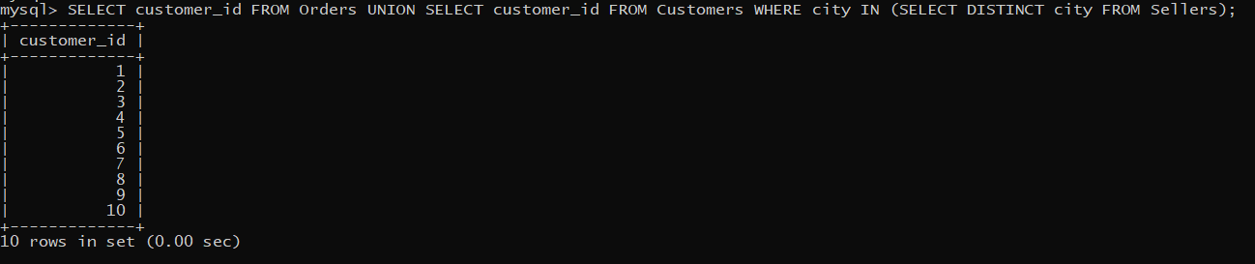

19. Retrieve all products that are either in stock with at least one seller or have been ordered
at least once.
(Hint: Use UNION between Product_Sellers and Order_Items.)
SELECT product_id FROM Products WHERE product_id IN (SELECT product_id FROM Product_Sellers) UNION SELECT product_id FROM Order_Items;
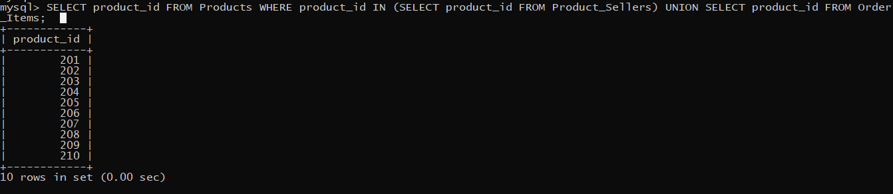

20. Retrieve products that have been both ordered and are currently in stock. (Hint: Use INTERSECT between Order_Items and Product_Sellers.)

SELECT product_id FROM Order_Items INTERSECT SELECT product_id FROM Product_Sellers;
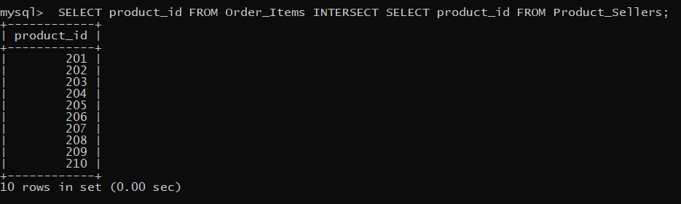

21. Find customers who have both placed an order and live in a city where a seller is located.
(Hint: Use INTERSECT between customers who have placed orders and customers who
live in a seller’s city.)
SELECT customer_id FROM Orders INTERSECT SELECT customer_id FROM Customers WHERE city IN (SELECT DISTINCT city FROM Sellers);
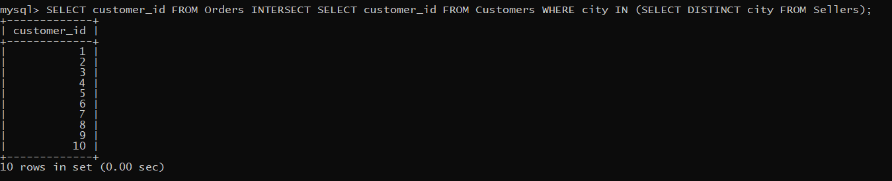

22. Retrieve all customers who have placed at least one order in each year available in the
database.
(Hint: Use INTERSECT with orders grouped by year.)
SELECT customer_id FROM Orders GROUP BY customer_id INTERSECT SELECT customer_id FROM Orders GROUP BY customer_id, YEAR(order_date);




